Order Of Service

Singing: Psalm 146—CW page 120

Reading: Psalm 64

Opening Hymn: CW 379

Reading: Acts 7:35-43

Request Hymn: CW Supplement 702

Reading: John 15:18-27

Sermon Hymn: CW 375

Sermon Text: Daniel 1:17-21

Ten Times Better

Prayer

The Apostles’ Creed, TLH page 12

Holy Communion

The Lord's Prayer

The Blessing

Closing Hymn: CW 327

* * * * * * * * * * *

Koinonia Hour
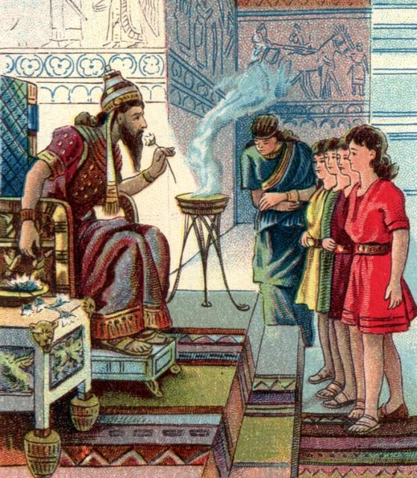

Ten Times Better

Water
Of
Life
3 December 2018

W A T E R O F L I F E

Independent Christian Church—Conservative Lutheran Doctrine

Worship Service: 9:30 a.m. Bible Study: 10:45 a.m.

Larry Cooper, Pastor E-Mail address:
111 N. Ridge Road lcooper@wateroflife.cc
Coon Valley, WI 54623 Web Site:
Phone: (608) 452-2105 www.wateroflife.cc

* * * * * * * * * * * * * * * * * * * * * * * * * * *

Sermon Text: Daniel 1:17-21

Ten Times Better

* * * * * * * * * * * * * * * * * * * * * * * * * * *

Related Reading—Matthew 13:10-17

10 And the disciples came, and said unto him, Why speakest thou unto them in parables?
11 He answered and said unto them, Because it is given unto you to know the mysteries of the kingdom of heaven, but to them it is not given.
12 For whosoever hath, to him shall be given, and he shall have more abundance: but whosoever hath not, from him shall be taken away even that he hath.
13 Therefore speak I to them in parables: because they seeing see not; and hearing they hear not, neither do they understand.
14 And in them is fulfilled the prophecy of Esaias, which saith, By hearing ye shall hear, and shall not understand; and seeing ye shall see, and shall not perceive:
15 For this people's heart is waxed gross, and their ears are dull of hearing, and their eyes they have closed; lest at any time they should see with their eyes, and hear with their ears, and should understand with their heart, and should be converted, and I should heal them.
16 But blessed are your eyes, for they see: and your ears, for they hear.
17 For verily I say unto you, That many prophets and righteous men have desired to see those things which ye see, and have not seen them; and to hear those things which ye hear, and have not heard them.

The Sower and the Seed

